A000-AFR-Egy-Ushabti-Blue Faience Trace-Deir El Bahri-Dyn 21-Third Intermediate Period, 1069-945 BCE

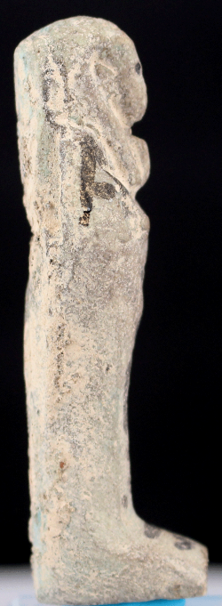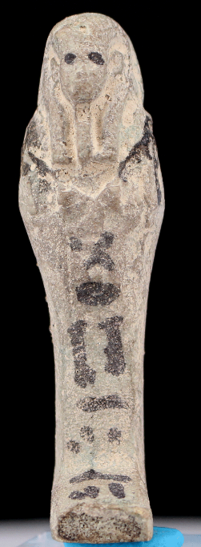 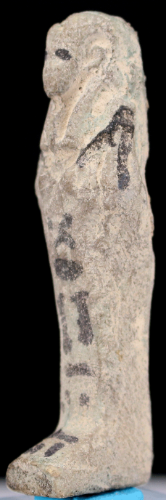 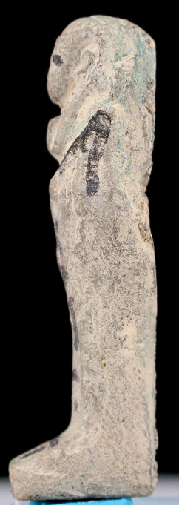 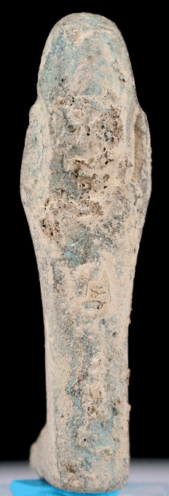

**Case no.: 2**

**Accession Number:**

**Formal Label:** Ushabti-Blue Faience Trace-Deir El Bahri-Dyn 21-Third Intermediate Period, 1069-945 BCE

**Display Description:**

Ushabti-Deir El Bahri-Dyn 21-Third Intermediate Period, 1069-945 BCE. See Schneider 1977: 4.5.1.3.

**LC Classification: NB 75**

**Date or Time Horizon:** Third Intermediate Period, 1069-945 BCE

**Cultural Affiliation:** Third Intermediate Period

**Media:** ceramic, Blue faience, Black ink

**Dimensions:** 62.12 mm, 2.47 in

**Weight: .25 oz, 10 gm**

**Condition: original**

**Provenance:**

**Discussion:**

The Third Intermediate Period was one of contesting parties. This left the artisans in precarious positions resulting in less developed capabilities of ateliers and less production of fine wares due to less expendable incomes.

**References:**

Schneider, H.D. 1977. *Shabtis: An introduction to the history of ancient Egyptian funerary statuettes with a catalogue of the collection of shabtis in the National Museum of Antiquities at Leiden*. Leiden: Rijksmuseum van oudheden.